**Semester Project Report**

**Face Mask Detector with OpenCV, Kera’s/ TensorFlow, and Deep Learning**

by

Hafiz Noor-ul-Hassan

BSCS-FA18-074

Advised by

Ms. Anum Nawaz



In partial fulfillment of the requirement for the

Bachelor of Computer Science

Department of Computational Science

THE UNIVERSITY OF FAISALABAD

June 15,2021

**Abstract**

COVID-19 is widespread and appears to affect more and more people. Mask use has become a new daily routine. Shortly, many utility users will need a face mask to use the service. Therefore, finding a face mask has become an important task to help the international community. This article provides an easy way to do this using basic machine learning packages such as TensorFlow, Cross, OpenCV, and Learning Skate. The recommended practice is to carefully mark the icon on your face and then make sure you are wearing the mask. As a watcher, it can also recognize moving faces. This method achieved accuracies of 95.77% and 94.58% on two different data sets, respectively. To accurately identify the presence of a mask, we are looking for modified parameter values using an existing sequential neural network model.

**Introduction**

According to the official WHO-205 report, the coronavirus (COVID-19) infected more than 20 million people worldwide in 2019, resulting in more than 700,000 deaths. People infected with COVID-19 have symptoms ranging from mild to severe. Shortness of breath, such as shortness of breath or shortness of breath, is one of these problems. Older people with lung disease are at higher risk and may have serious complications from COVID-19. Some of the most common human coronaviruses infect people around the world. Anyone with respiratory problems can come into contact with infectious granules (close contact). In the vicinity of an infected person, the use of a medical mask is essential to combat some respiratory viral diseases, including COVID-19, because virus-carrying droplets can reach nearby surfaces. This area can cause contact infections. People should know that they are using masks to control the source or hate of COVID-19. Potential problems associated with mask use include reducing the risk of exposure to at-risk individuals in the "asymptomatic" stage and limiting the spread of the virus by stigmatizing masked individuals. Who advocates prioritizing medical and respiratory equipment for healthcare workers? Therefore, the search for face masks has become a primary challenge for the global community today. Face mask detection involves finding a face and then checking to see if the face has a mask. The problem is almost entirely related to object detection common to the Object class. It is clear that facial recognition belongs to a certain group of people, i.e., facial recognition, and has many uses, such as autonomous vehicles, exercise, and surveillance. TensorFlow, Kera’s, OpenCV, Scikit-Lear, Like Learning (ML).

**Dataset**

Dataset contain of 4095 images belonging two class

* + With Mask: 2,165 images

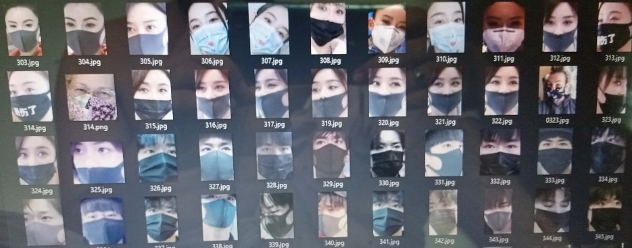

* + Without Mask: 1,930 images

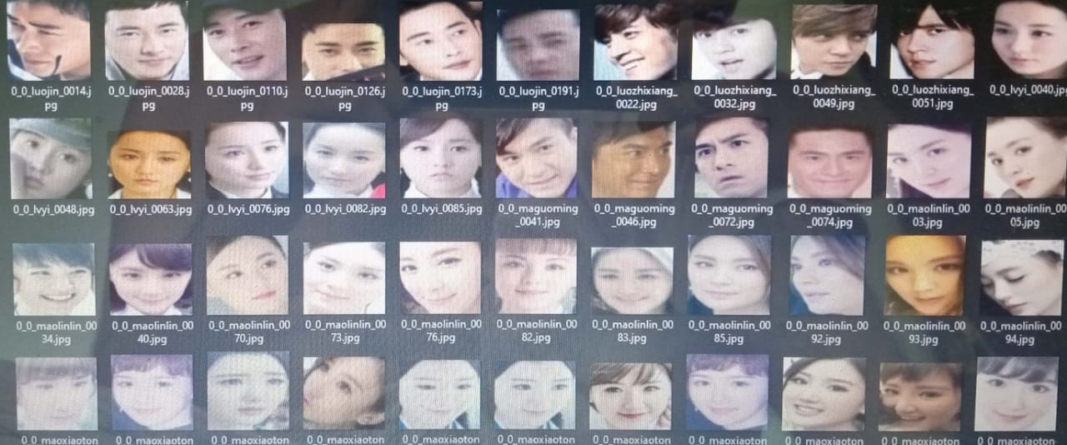

**Incorporated Packages**

* **TensorFlow**

TensorFlow, a fast and expressive interface to machine learning algorithms, is used to implement ML systems in various processing domains, such as sentiment analysis, speech recognition, geographic information extraction, computer visualization, and word and computer processing. Includes data retrieval and extraction. Error for further investigation. In the proposed model, the entire serial architecture of CNNs (including multiple layers) uses TensorFlow in the background. It is also used to transform data (images) into processing.

* **Kera’s**

Kerry offers basic reflections and unity parts for the construction and transport of high-speed repetition ML regulators. This uses the best use of her husband's rivers and her husband's facilities for platforms. The basic structure is in the model and model. All levels used in the CNN model are made of white oil. Data processing uses the transfer of the tank for the classmate's binary in normal OpenCV.

* **OpenCV**

Ein open-source computer vision an ML software bibliotheca, recognizing and recognizing faces, identifying objects, group movements in the record, tracking progressive modules, following eye gestures, tracking camera action, Images are used to extract red eyes from used images to find glowing comparative images. Evaluate an image database, landscape and create it with augmented reality and markers to move forward with it. The proposed method uses these features of OpenCV to resize and resize data images.

**The Proposed Method**

The proposed method consists of a pre-trained CNN consisting of two 2D convolutional layers connected by cascade classification and dense neuronal layers. The face mask detection algorithm is as follows.

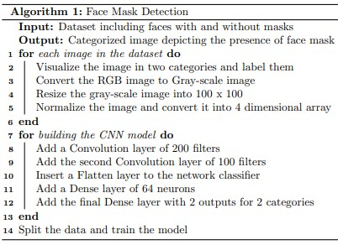

**Data Processing**

Data pre-processing is the process of transforming data from a specific format into an accessible and meaningful format. It can be any formats such as tables, images, videos, graphs, etc. This structured information is presented in informational or structured form and reflects the relationships between the various institutions. The proposed method uses image and video data using NumPy and OpenCV.

* **Data Visualization**

Data visualization is the process of transforming abstract data into meaningful representations through cognitive communication and information discovery through coding. It is useful to examine some models in the dataset.

* **Convert RGB image to grayscale image**

Modern descriptor-based image recognition systems process grayscale images every day without describing the process of converting colors to grayscale. In fact, the grayscale method has little effect when using strong descriptors. "Additional information can be entered to increase the training data needed for good performance. Grayscale justifies the algorithm and reduces computation by inserting color images instead of processing them." You have to take the baby. Experiment is in progress."

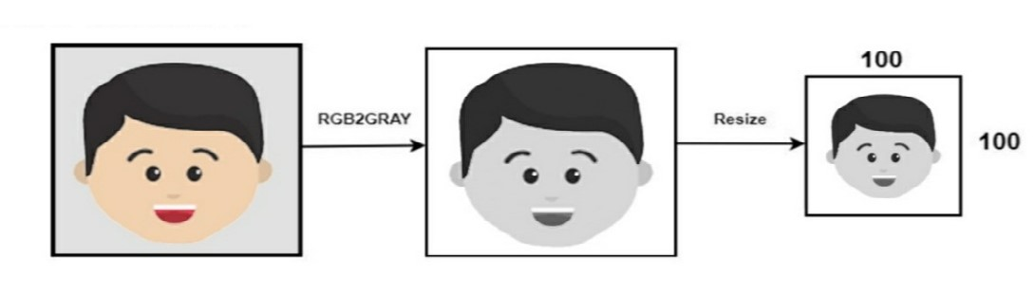

Use the cv2.cvtColor(input image, flags) function to change the color space. Here, the label defines the type of transformation. In this case, use the cv2.COLORBGR2GRAY flag to convert to gray. Deep CNNs require fixed-size input images. Therefore, all images in the data set must have a constant size. cv2.resize() resizes the grayscale image to 224 x 224.

**Face Net or Mask Net**

a) Face Net is a face recognition pipeline that learns to map faces in a multidimensional space from a point where the distance between the points is directly equal to the measurement of the face.

b) As a result, mask networks are an efficient way to control the subtotal group entries used in traditional concatenation algorithms. An interesting feature of this pipeline is that the mask network and the concatenation algorithm are independent of each other and can be trained separately.

**Training of Model**

Modelling with CNN Architecture: CNN’s have become leaders in various areas of computer vision. The current test uses a continuous CNN. The first level of convolution follows the REL (linear correction level) and maximum clustering level. The convolution level learns from 200 filters. The kernel size is set to 3 x 3, which determines the height and width of the 2D twist window. The first level of the model must provide information about the input-form, as the model must recognize the expected input form. The next step is to perform an intuitive calculation [13]. In this case, the input mask is provided as data. Figure [1]: The data in Figure 1 shows the size of the table. The standard padding is "true", you can truncate the local size and zero pad the input size. The trigger parameter of the Conv2D class is set to "read". This is a linear function that has almost all the advantages of a linear model and can be easily applied by reducing the incremental method. Because of the power and generality of deep learning, it outperforms other activation functions. The max pool is used to reduce the amount of space on the output volume. The pool size is set to 33 3 and the output has the following format (number of rows or columns): Output pattern = (input format - pool size + 1) / step), default step (1 x 1) second layer convolution filter is 100 and kernel size is set to 33. Here are the ReLu and Max pooling layers. A long vector is passed through the flattened layer to fill the CNN with data. The flattened layer transforms the attribute matrix into a vector that can be inserted into a fully connected neural network classifier. A stall is added to the model and the amount of sedimentary layer is reduced, giving a zero-input probability of 50%. Next, a dense layer of 64 neurons with REL activation function is added. Last layer

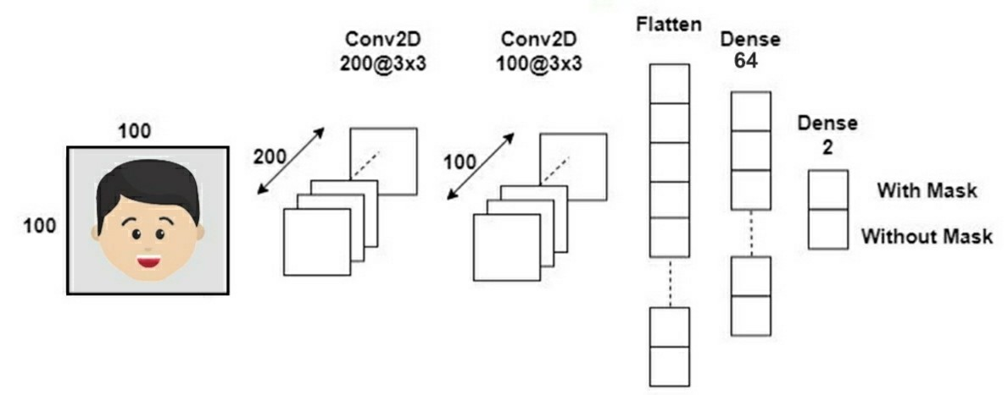

Convolutional Neural Network architecture

The learning process must first be structured as a transformation method. An amplifier is used here. Classified cross-entropy, also known as stratified deforestation debris, is used as a loss function (what the model is trying to minimize). Since this is a classification problem, the scale is set to "correct". b) Data segmentation and training CNN model: After preparing the graph for data analysis, you need to train the model on one dataset and then test it on the other dataset. The right model and optimal classification of tensile tests will help you get accurate results in your predictions. The test size is fixed at 0.1. H. 90% of the dataset is trained and the remaining 10% are tested. Validation losses are handled using model checkpoints. Next, the training set and test set images are placed on the production model. Here, 20% of the training data is used as validation data. The model has been trained on over 20 courses to strike a balance between accuracy and potential (common) abuse.

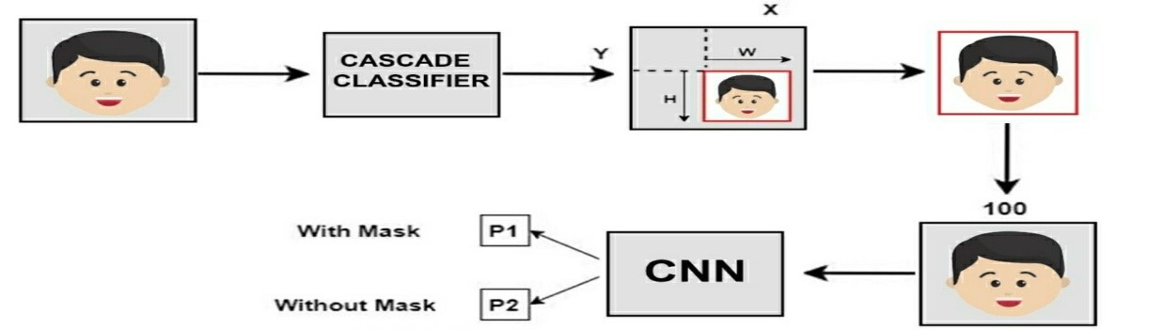

**RESULT AND ANALYSIS**

The model was tested on two datasets: training, validation, and testing. Unlike dataset 1, this method achieves an accuracy of 95.77%, and this increased accuracy demonstrates how to minimize the cost of error. Dataset 2 is different than Dataset 1 because the frame has multiple faces and different colors depending on the mask type. Thus, the dataset 2 model achieves an accuracy of 94.58% because it reflects the differences between training and loss of validity associated with dataset 2. The main reason for this accuracy is maximum voter turnout. This provides default transformation constants for internal performance and reduces the number of model parameters to be trained. This alternative sample-based process reduces the size of the input that composes the image. The optimal number of neurons is 64, which is not very high. Too many neurons and filters can degrade performance. Optimized filter values ​​and pool sizes allow you to filter the body (face) of the image to correctly detect the presence of a mask without oversetting.

.

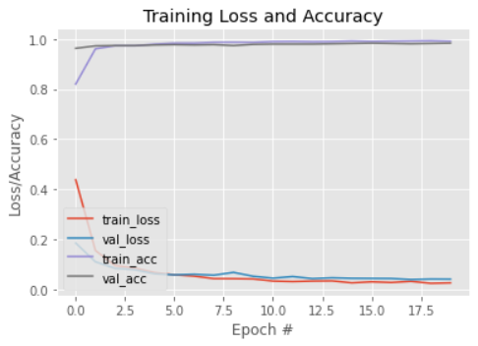

#Epoch Training Loss and Accuracy

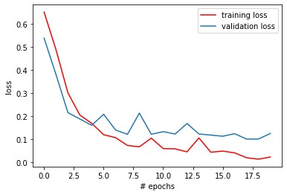

# Epochs vs loss corresponding to dataset 1

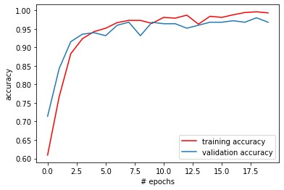

# Epochs vs accuracy corresponding to dataset 1

The system can partially recognize a mask, hair, or face with an obscured hand. Fringe detects the degree of impairment in four areas: nose, mouth, chin, and eyes and identifies faces that are occluded or occluded by hands. Therefore, a mask that covers the entire face, including the nose and chin, is considered a "mask" only by the exhibitor.

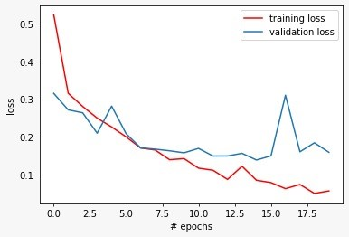

# Epochs vs loss corresponding to dataset 2

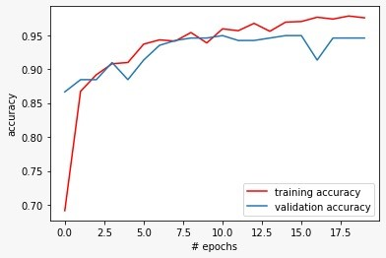

The main problems with this method are mainly angular differences and opacity. The vague animated faces in the video feed make this difficult. However, "masked" or "unmasked" resolution can be improved by following the path of other frames.

**CONCLUSIONS**

This article briefly explains why it works. The following steps demonstrate the performance of the training activity and the model. Using basic ML tools and simple techniques, this method achieves a relatively high level of accuracy. It can be used for various purposes. The COVID-19 emergency may require the use of masks shortly. Many utility providers need the right mask to serve their customers. The models used play an important role in public health systems. In the future, this could be extended to make sure someone is wearing the mask correctly. This model can be further refined to determine whether the mask is susceptible to virus infection, i.e., whether the mask type is surgical or N95.

**Reference**

1. "Corona Virus 2019 (Covid-19): Situation Report 205", 202

* Detail
* [Google](https://scholar.google.com/scholar?as_q=Coronavirus+disease+2019+%28covid-19%29%3A+situation+report%2C+205&as_occt=title&hl=en&as_sdt=0%2C31)

1. In the face detection method, a face detects an image that has many features.

* Detail

1. Collection the All-images Dataset

* [Kaggle](https://www.kaggle.com/datasets?search=face+mask+detection)
* [RMFD dataset](https://github.com/X-zhangyang/Real-World-Masked-Face-Dataset)
* [Bing Search API](https://www.microsoft.com/en-us/bing/apis/bing-web-search-api)

1. TensorFlow White Papers", *TensorFlow*, 2020, [online] Available

* Detail
* [Google](https://scholar.google.com/scholar?as_q=TensorFlow+White+Papers&as_occt=title&hl=en&as_sdt=0%2C31)

1. "Kera’s Documents: About Kera’s", 2020, [online] Available: Karasu

* Detail
* [Google](https://scholar.google.com/scholar?as_q=Keras+documentation%3A+About+Keras&as_occt=title&hl=en&as_sdt=0%2C31)

1. OpenCV ", 2020, [online] Available: OpenCV.

* Detail
* [Google](https://scholar.google.com/scholar?as_q=OpenCV&as_occt=title&hl=en&as_sdt=0%2C31)

1. **"**TensorFlow White Papers", TensorFlow, 2020, [online] Available

* Detail
* [Google](https://scholar.google.com/scholar?as_q=An+approach+to+face+detection+and+recognition&as_occt=title&hl=en&as_sdt=0%2C31)